**Anaconda Installation Guide**

Click the following link: <https://www.anaconda.com/products/individual#Downloads> and download the version your system is compatible with. Then follow the steps below, only the popups where you have to make a choice are displayed.

Install for “Just me”

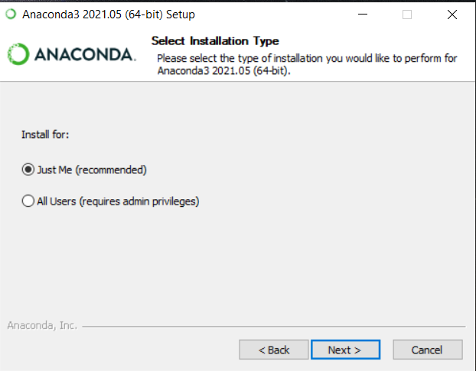

Choose your folder, preferably something in your user specific folder (C:\Users\”your-user-name”)

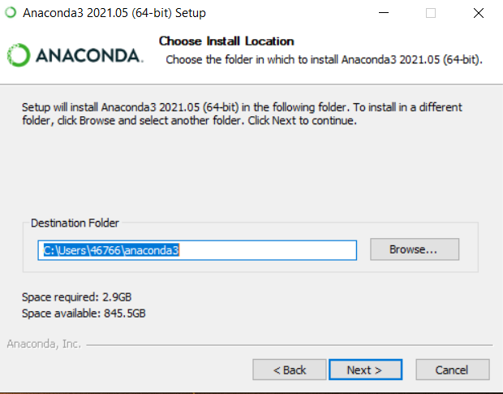

Select “Register Anaconda 3 as my default Python 3.8”

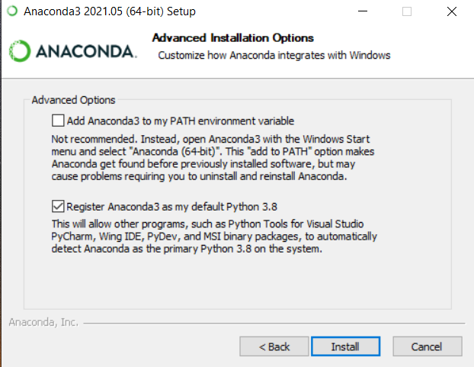

For some handy tips you can checkmark the below options

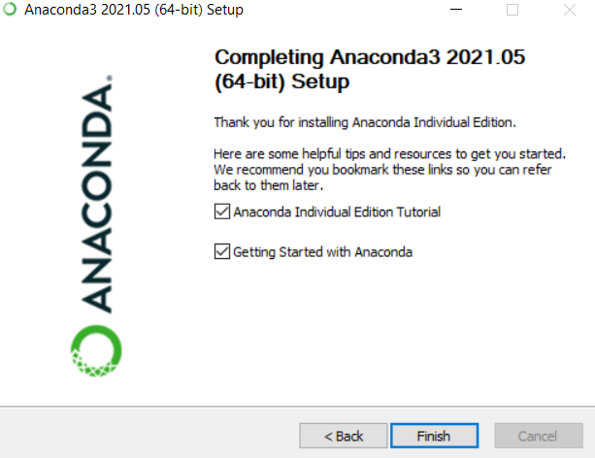

Nicely done! You have now installed Anaconda!:) You can launch it by searching for Anaconda Navigator and then run the application. You should see several programs here, amongst them Jupyter Notebook which we will be using in this course.